DOCUMENTATION ON THE PRACTICAL TASK FOR MOBILE APPLICATION DEVELOPMENT

Developer: Gathura Moffat Mwangi
Registration Number: BIT/2025/67965
Unit: Mobile App Development
Date: 09 June 2026

Documentation
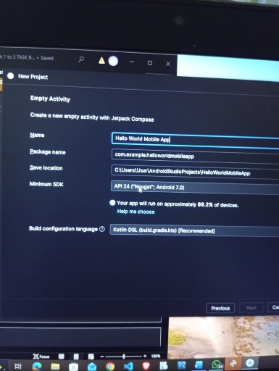
Initializing the project wizard in android studio
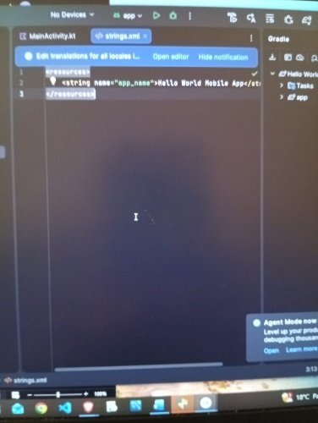
Defining application core text resources
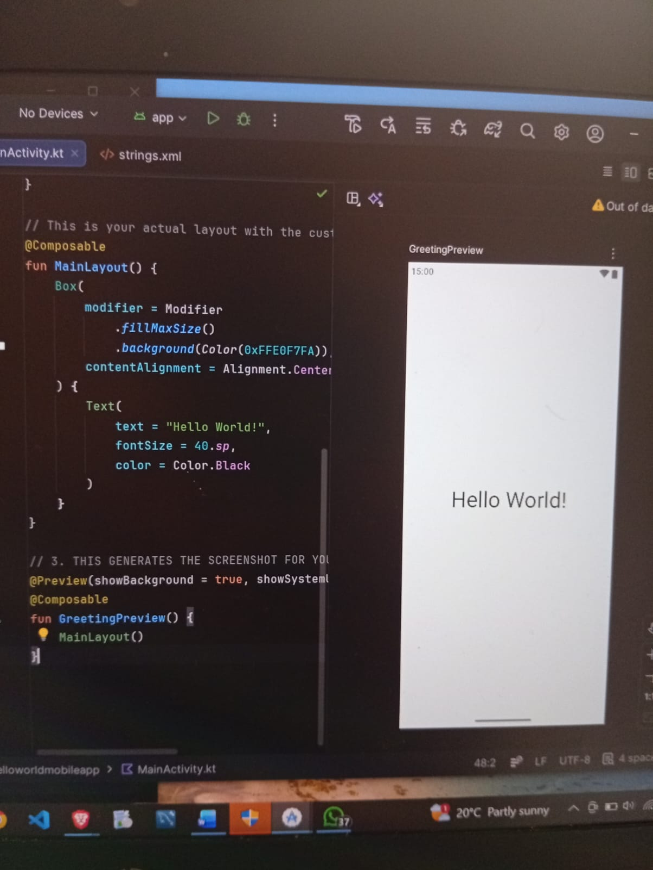
Constructing the Base UI Layout preview
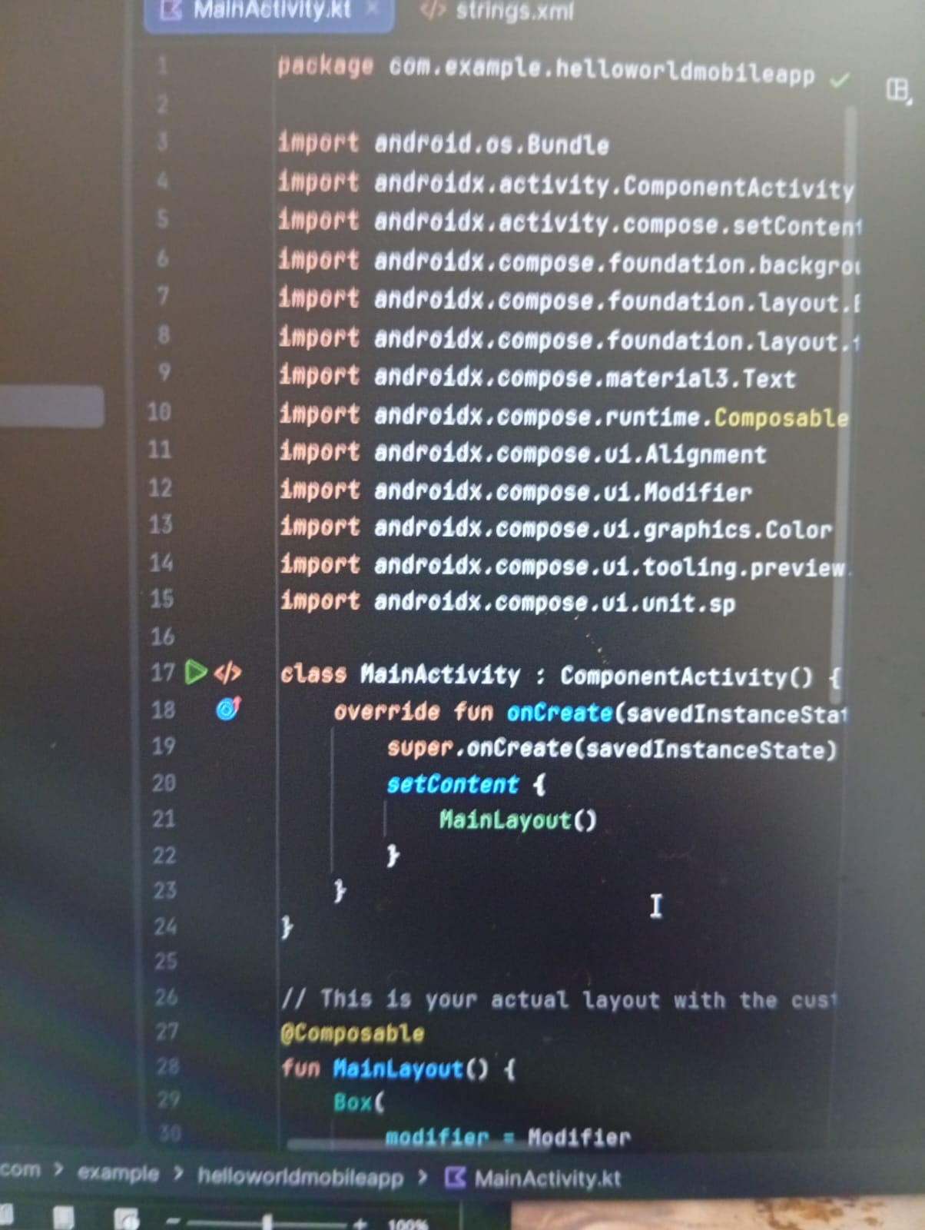
Main activity entry point implementation
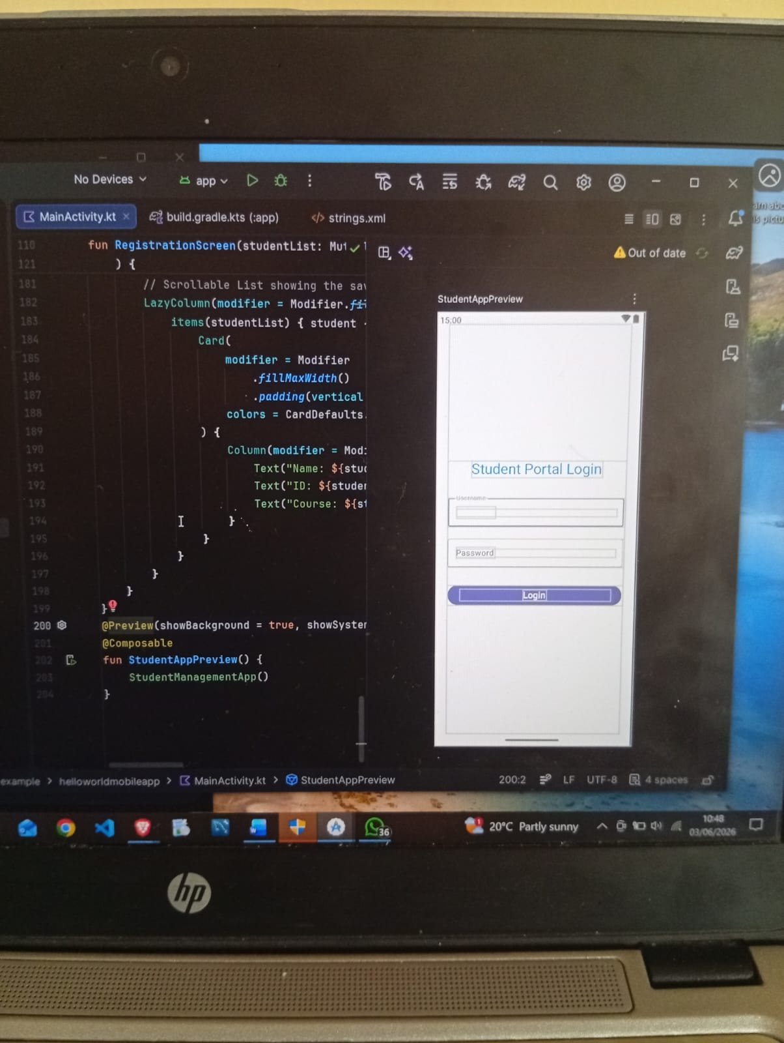
Developing the student portal login screen
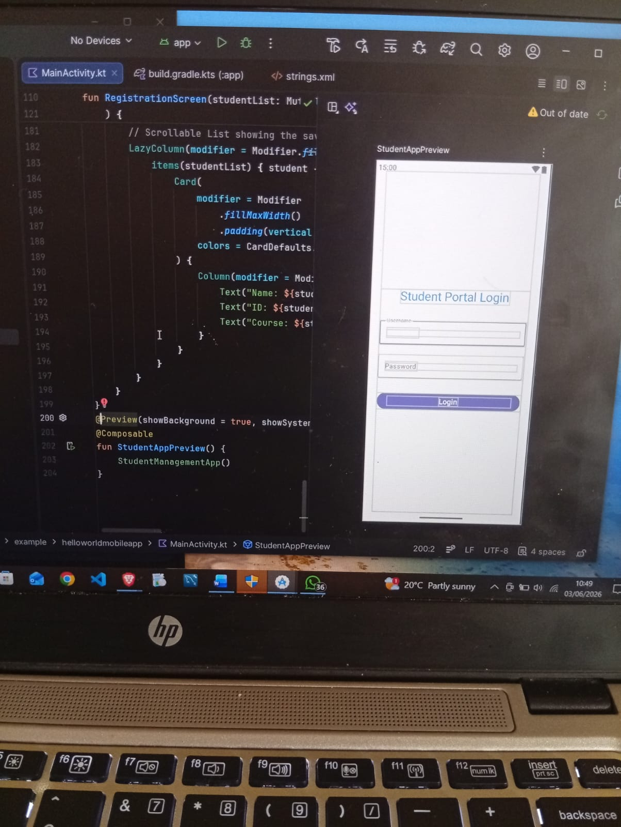
Previewing and testing layout alignment
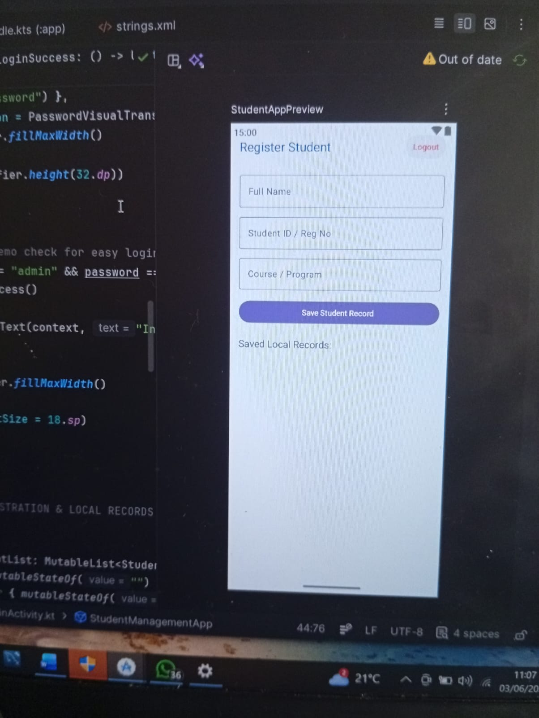
Designing the student registration interface
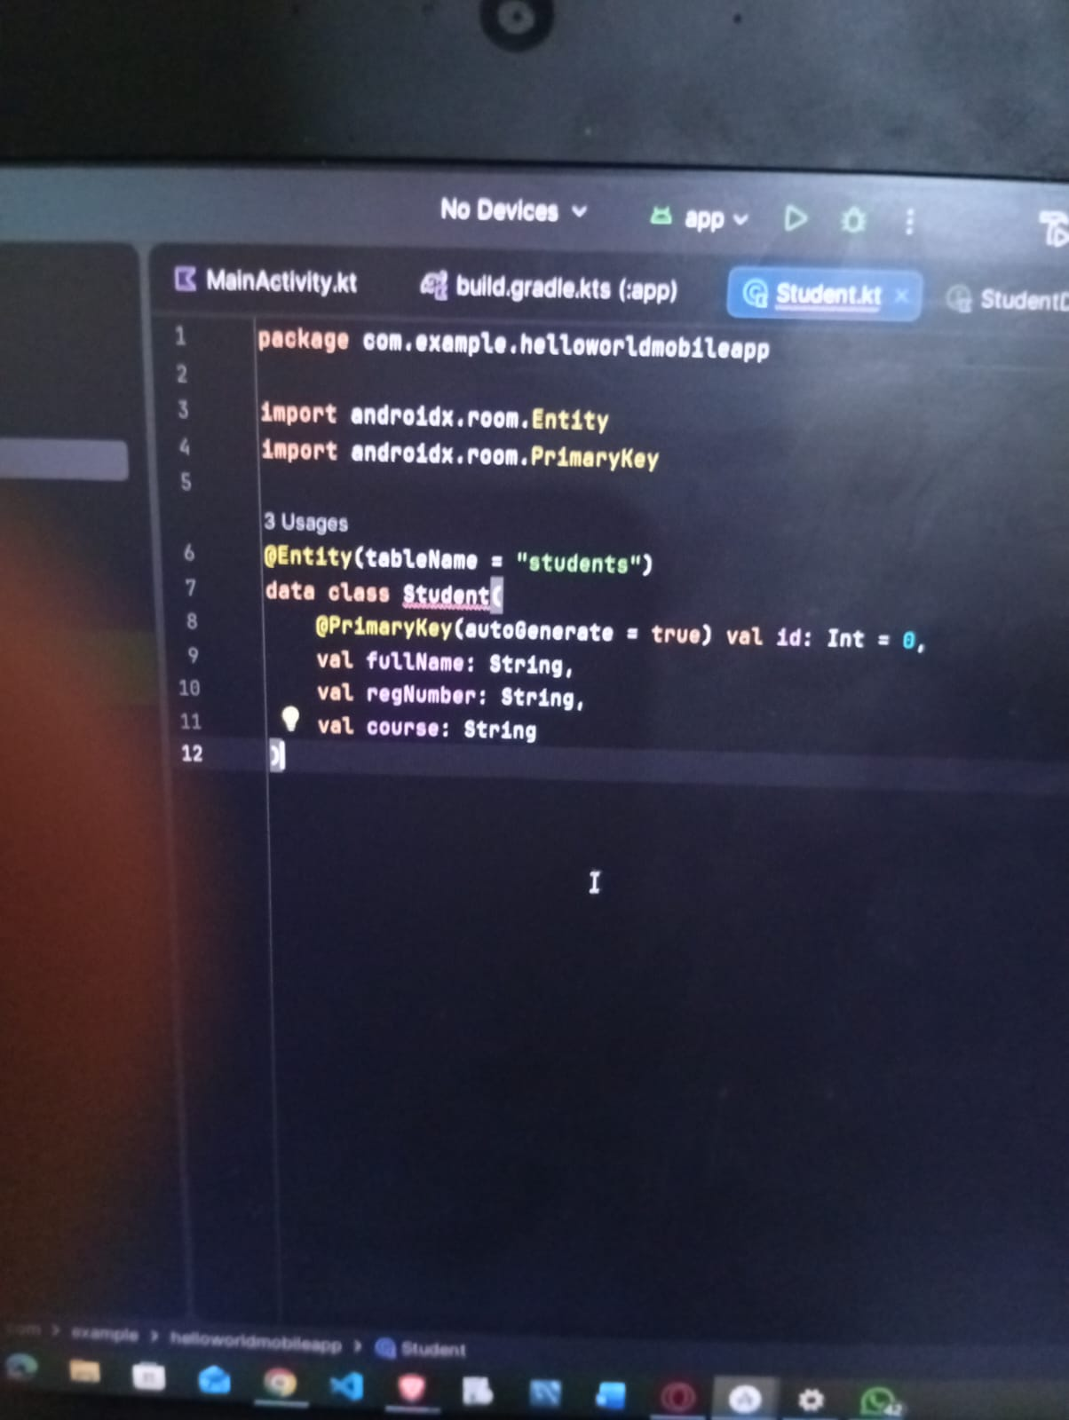
Implementing the room database entity model

